SG CSA CCoP Compliance for Log360
Strengthen data protection and meet SG CSA CCoP compliance with Log360.
Region: Singapore | Type: Data Privacy, Critical Infrastructure, Incident Management | Category: Compliance | Pricing: Free

Overview
The SG CSA CCoP compliance extension in Log360 helps organizations meet the Cybersecurity Code of Practice for Critical Information Infrastructure (CCoP 2.0, Singapore CSA), Singapore's mandatory cybersecurity code specifying minimum requirements for CII owners across 11 critical sectors, effective July 2022 by providing centralized log management, real-time security monitoring, and comprehensive audit capabilities. The platform supports SG CSA CCoP requirements for governance, asset identification, access control, threat detection, incident response, network security, data protection, and vulnerability management.
For Governance and Security Management, Log360 tracks AD user auditing, GPO configurations, group and OU management, computer auditing, and policy changes to evidence governance. To address Asset Identification and Risk Assessment, the platform monitors Windows program inventory, software update status, registry changes, computer auditing, and vulnerability scanner integration. The extension also supports Access Control and Identity Management by providing capabilities that captures Windows and Unix logon/failed logon events and AD and Entra ID MFA logon compliance reports.

Key Features
- Security Monitoring and Detection: Log360 delivers threat detection via FireEye, Trend Micro, Windows/Unix threat reports, and network attack monitoring.
- Incident Response and Recovery: Log360 monitors Backup and Disaster Recovery infrastructure, job statuses, and Windows Backup events alongside FireEye threat data.
- Network Security and OT Protection: Log360 audits network device logon, account management, policy changes, attack reports, and firewall security configurations.
- Data Protection and Endpoint Security: Log360 tracks file changes, Windows registry modifications, USB storage auditing, Unix removable disk activity, and endpoint threat reports.
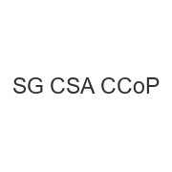
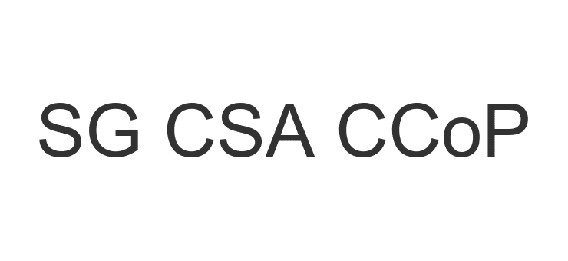
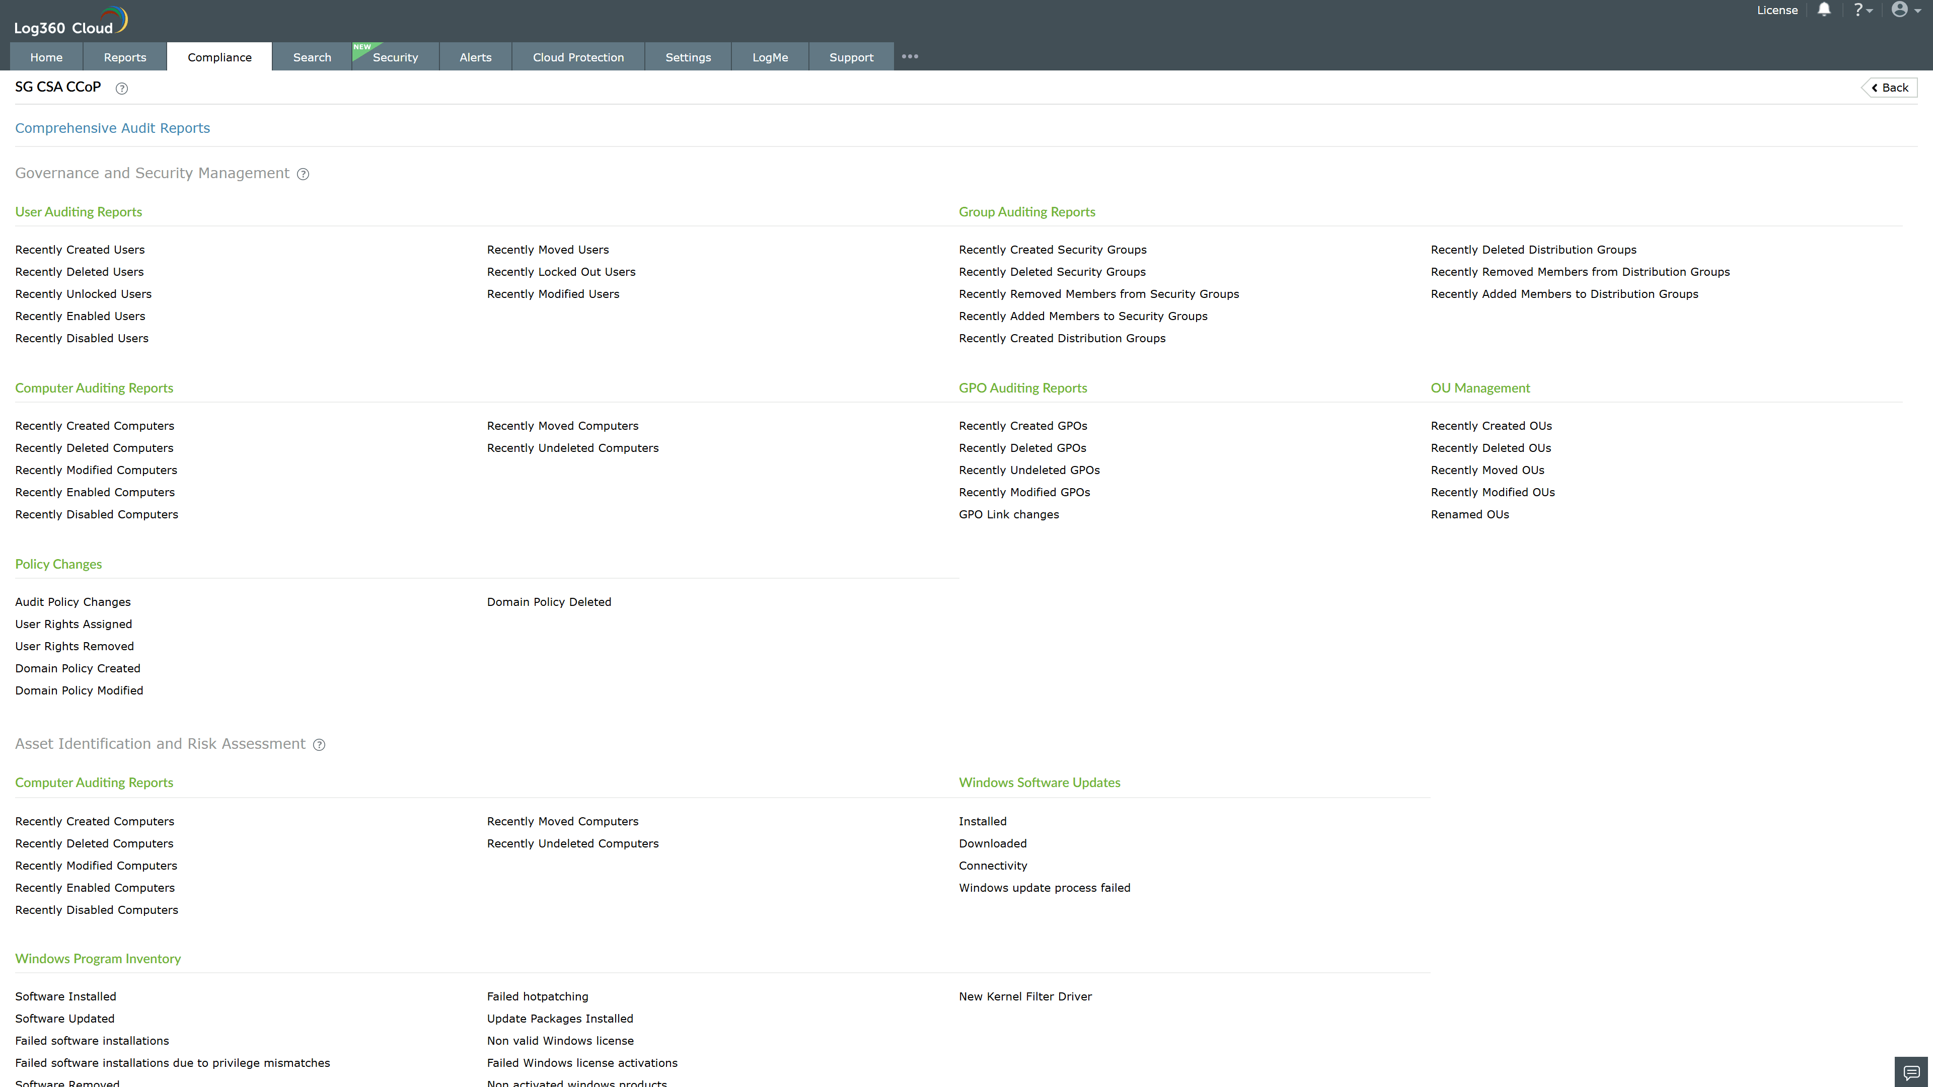
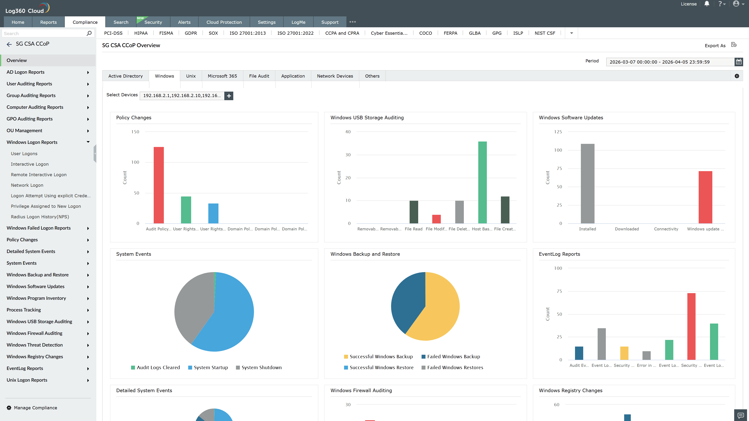
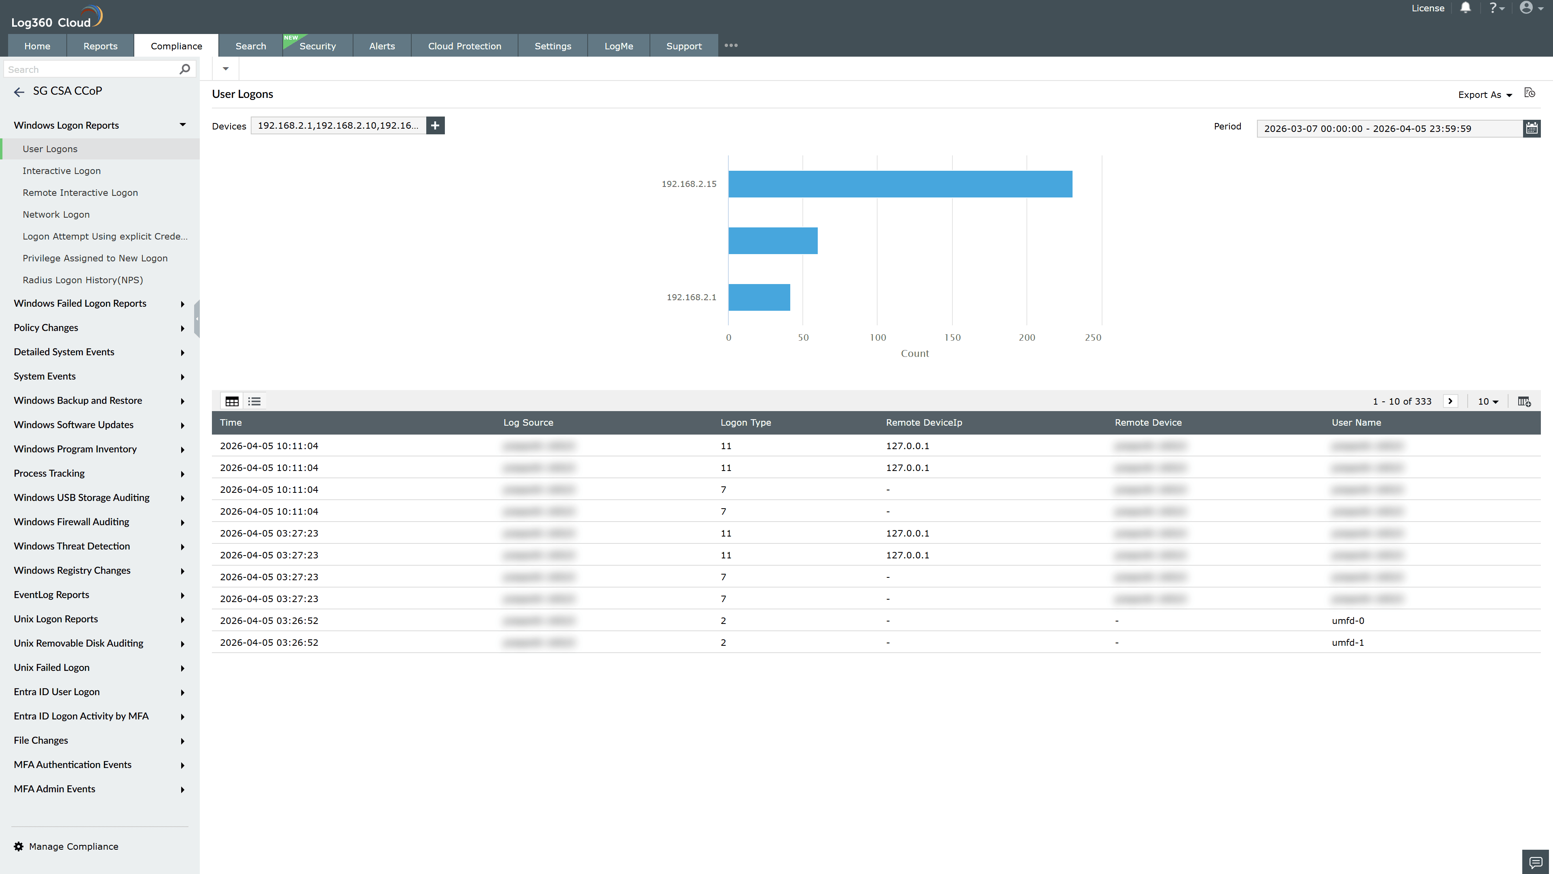
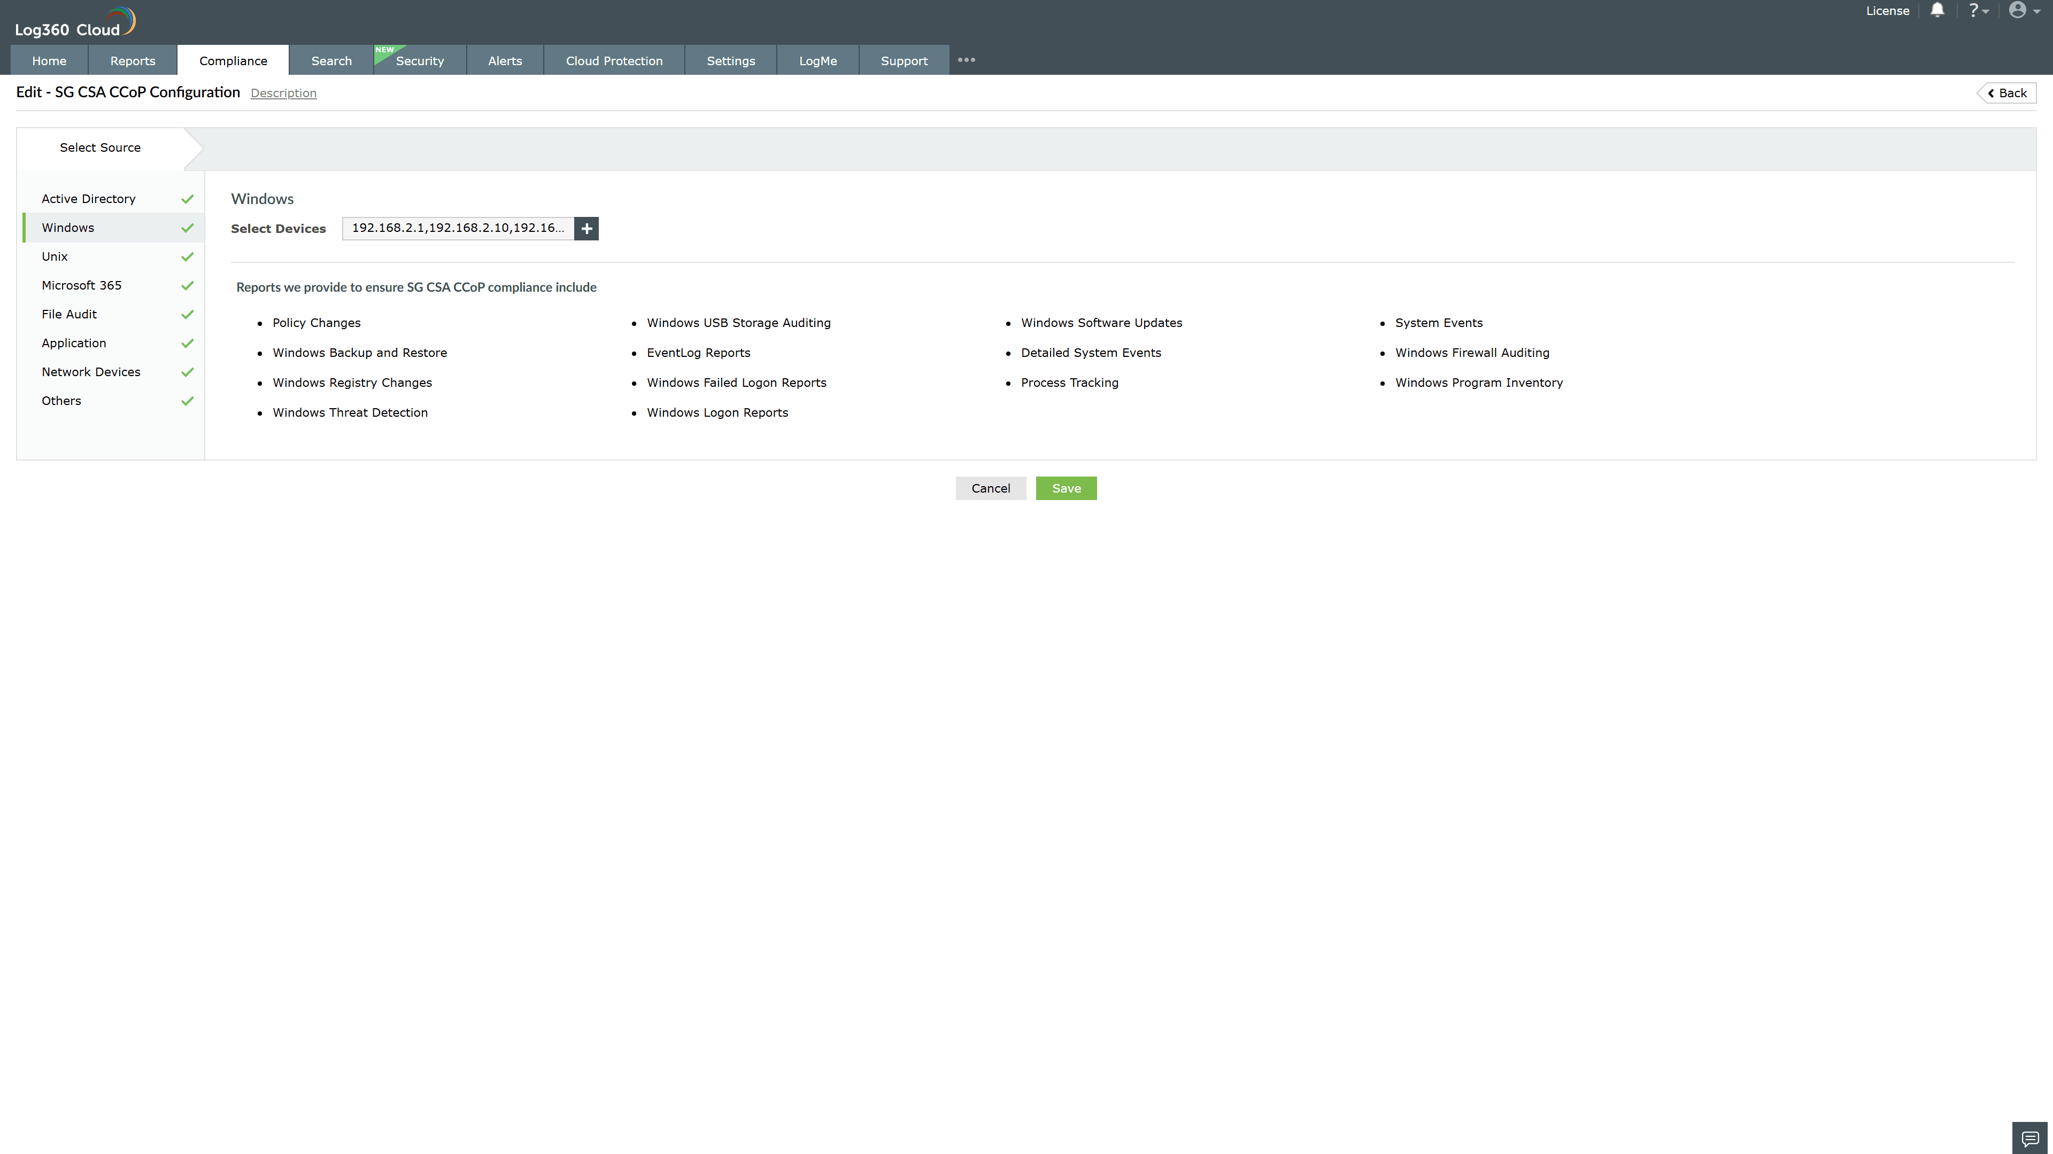
Valid Submission : Yes
Supported Editions : Free, Basic, Standard, Professional, MSSP
Help Document : https://www.manageengine.com/log-management/help/integrations/compliance-extensions.html
Help Video : Not provided
Tags : Log360, Compliance, Privacy monitoring, Data privacy, Regulatory compliance
Supported DCs : US, IN, JP, CA, AU, UK and EU
Privacy Policy:
Terms of Service:
Release Notes:
Predefined reports for the SG CSA CCoP.

